Rossmoyne Senior High School

Semester One Examination, 2014

Question/Answer Booklet

MATHEMATICS 3C
SOLUTIONS

Section One:

Calculator-free

Student Number: In figures

In words

Your name

Time allowed for this section
Reading time before commencing work: five minutes
Working time for this section: fifty minutes

Materials required/recommended for this section

To be provided by the supervisor
This Question/Answer Booklet
Formula Sheet

To be provided by the candidate
Standard items: pens, pencils, pencil sharpener, eraser, correction fluid/tape, ruler, highlighters

Special items: nil

Important note to candidates

No other items may be used in this section of the examination. It is your responsibility to ensure that you do not have any unauthorised notes or other items of a non-personal nature in the examination room. If you have any unauthorised material with you, hand it to the supervisor before reading any further.

Structure of this paper

Section | Number of questions available | Number of questions to be answered | Working time (minutes) | Marks available | Percentage of exam
Section One:  Calculator-free | 7 | 7 | 50 | 50 | 33⅓
Section Two:  Calculator-assumed | 12 | 12 | 100 | 100 | 66⅔
 |  |  | Total | 150 | 100

Instructions to candidates

- The rules for the conduct of Western Australian external examinations are detailed in the Year 12 Information Handbook 2013. Sitting this examination implies that you agree to abide by these rules.

- Write your answers in the spaces provided in this Question/Answer Booklet. Spare pages are included at the end of this booklet. They can be used for planning your responses and/or as additional space if required to continue an answer.
- Planning: If you use the spare pages for planning, indicate this clearly at the top of the page.
- Continuing an answer: If you need to use the space to continue an answer, indicate in the original answer space where the answer is continued, i.e. give the page number. Fill in the number of the question(s) that you are continuing to answer at the top of the page.

- Show all your working clearly. Your working should be in sufficient detail to allow your answers to be checked readily and for marks to be awarded for reasoning. Incorrect answers given without supporting reasoning cannot be allocated any marks. For any question or part question worth more than two marks, valid working or justification is required to receive full marks. If you repeat an answer to any question, ensure that you cancel the answer you do not wish to have marked.

- It is recommended that you do not use pencil, except in diagrams.

Section One: Calculator-free (50 Marks)
This section has seven (7) questions. Answer all questions. Write your answers in the spaces provided.

Working time for this section is 50 minutes.

Question 1 (5 marks)
Express 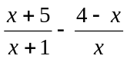 as a single algebraic fraction, with both the numerator and denominator factorised as far as possible.

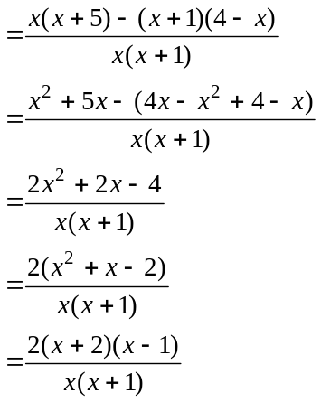

Question 2 (8 marks)
The function with derivative 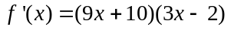 passes through the point (1, 2).

(a) Determine the equation of the tangent to the graph of 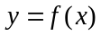 at the point where 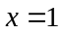.
(2 marks)
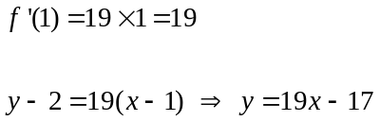

(b) Determine the equation of the function . (3 marks)

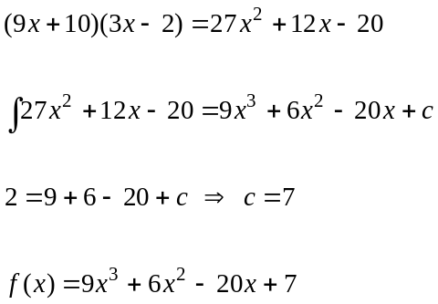

(c) Calculate the coordinates of the minimum turning point of the graph of .
(3 marks)
Stationary points when 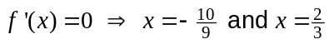.

As is a cubic, minimum must be when 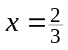.

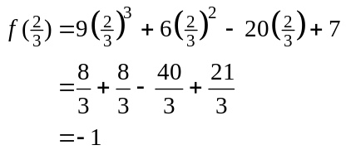

Minimum is at 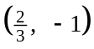.
Question 3 (9 marks)
(a) Determine

(i) 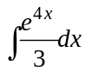 (2 marks)
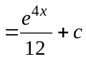

(ii) 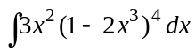 (3 marks)
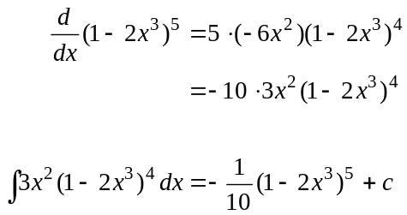

(b) The graphs of 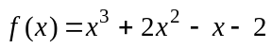 and 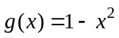 are shown below. Determine the area enclosed by the two functions between 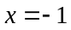 and . (4 marks)
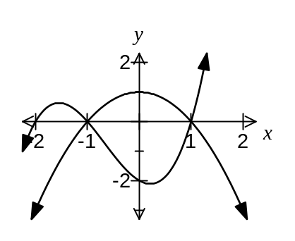
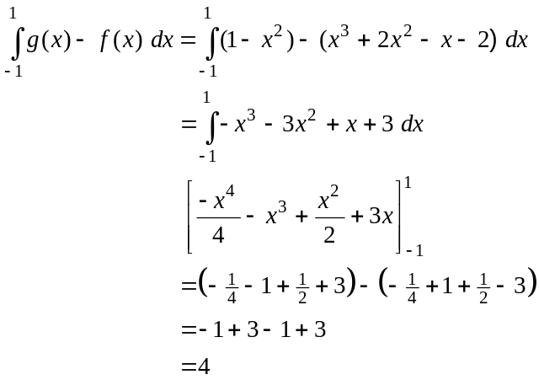

Question 4 (5 marks)
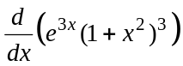 can be written in the form 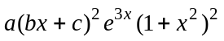.

Determine the values of 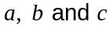.

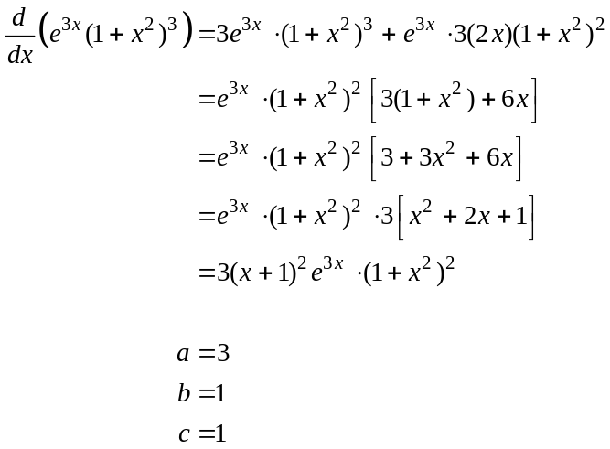

Question 5 (8 marks)
The graph of the function is shown below for 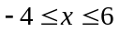.
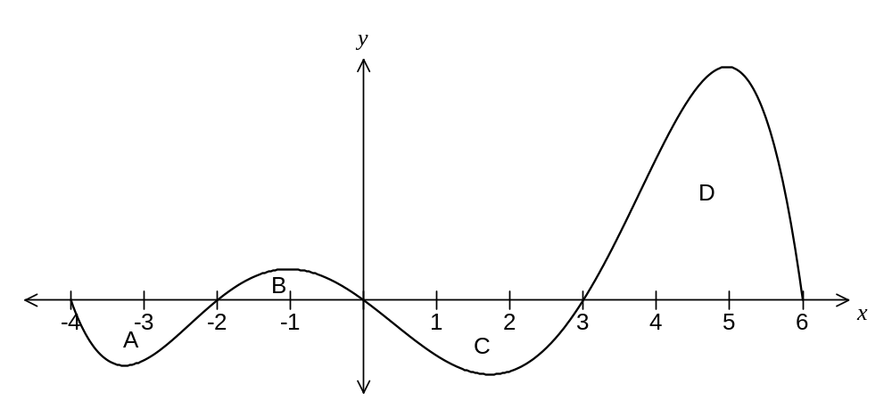
The area of each region enclosed by the curve and the -axis is shown in the following table.

Region | A | B | C | D
Area of region | 5 | 3 | 11 | 25

(a) Determine the area enclosed between the graph of and the -axis, from 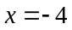 to 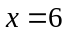. (2 marks)
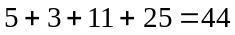

(b) Determine the value of

(i) 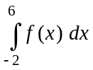. (2 marks)
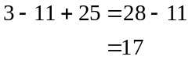

(ii) 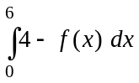. (2 marks)
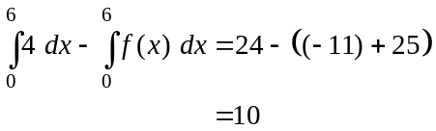

(iii) 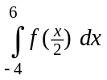. (2 marks)
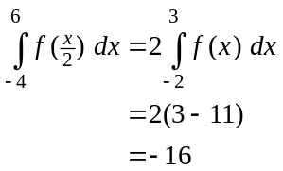

Question 6 (8 marks)
A polynomial function 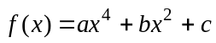, where are real constants, has the following features:

- 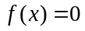 only for 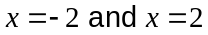
- 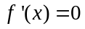 only for 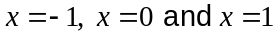
- 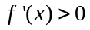 only for 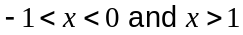
- 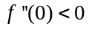

(a) At the point where the curve intersects the -axis, is it concave up or concave down? Explain your answer. (2 marks)

Concave down, since .

(b) Is positive or negative? Explain your answer. (2 marks)
is -intercept and must be negative.

Only two roots, so between function must always be below -axis, as continuous and gradient at 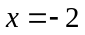 is -ve and at 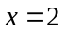 is +ve.

(c) Sketch a possible graph of the function on the axes below. (4 marks)
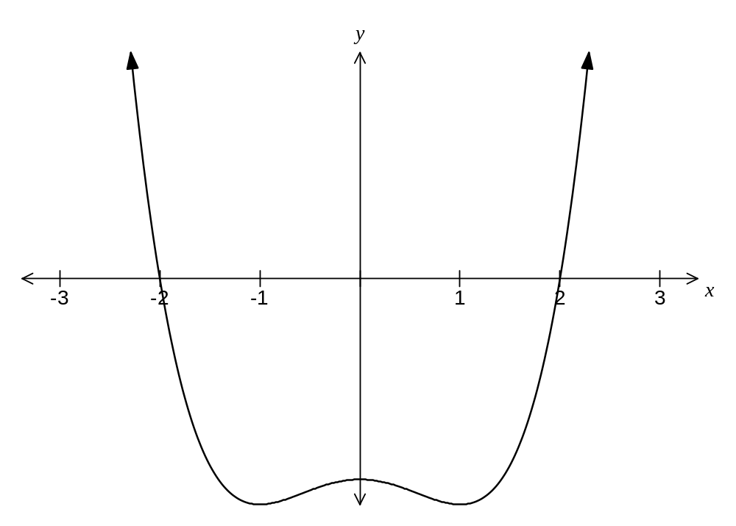

Question 7 (7 marks)
The height of a solid metal cylinder is equal to its diameter.

(a) Show that the total surface area, , of the cylinder is given by 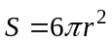. (1 mark)
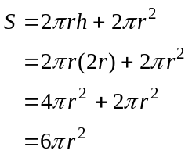

(b) Using the formula 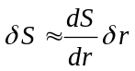, show that when the radius of the cylinder increases by 2%, the approximate percentage increase in the total surface area of the cylinder is 4%.
(4 marks)
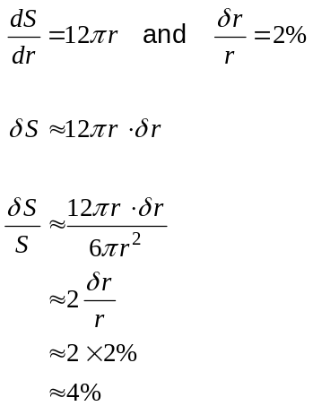

(c) Explain why the increments formula in (b) would not produce a suitable approximation for the increase in total surface area if the radius increased from 10 cm to 15 cm. (2 marks)

Because the increase from 10 cm to 15 cm is a large (50%) change. The increments formula is only suitable for small changes.

Additional working space

Question number: _________

Additional working space

Question number: _________

This examination paper may be freely copied, or communicated on an intranet, for non-commercial purposes within educational institutes that have purchased the paper from WA Examination Papers provided that WA Examination Papers is acknowledged as the copyright owner. Teachers within Rossmoyne Senior High School may change the paper provided that WA Examination Paper's moral rights are not infringed.

Copying or communication for any other purposes can only be done within the terms of the Copyright Act or with prior written permission of WA Examination papers.

Published by WA Examination Papers
PO Box 445 Claremont WA 6910

